System Architecture Styles:

* Client/Serve
* Peer to peer

Message based communication:

* Message passing
* Remote Procedure call (RPC)
* Distributed Objects
* Web services

**RPC Reference Model:**

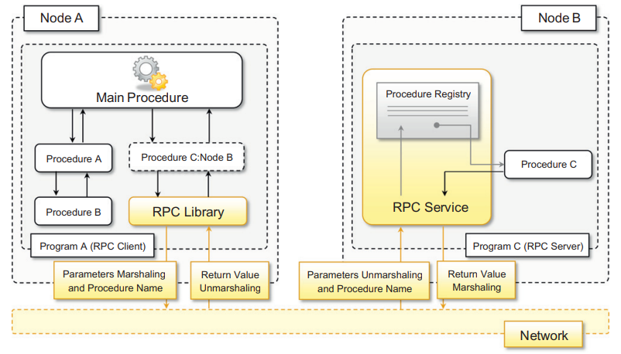

**Distributed Object Programming Model:**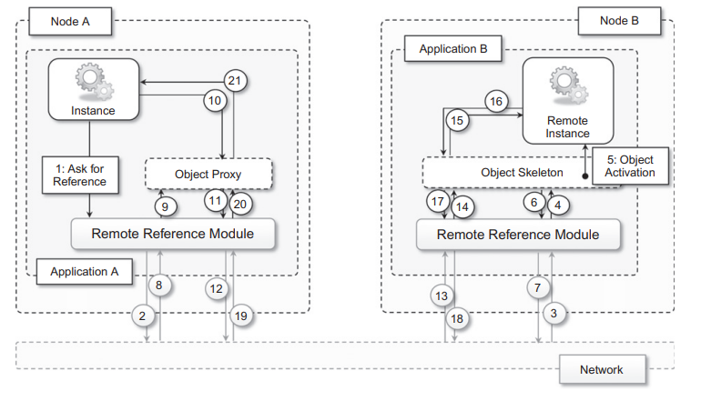

Service Oriented Computing: (SOA) What is service?

**Web Service:**

**Boundaries are explicit, services are autonomous, service share schema and contracts, not class or interface definition, services compatibility is determined based on policy.**

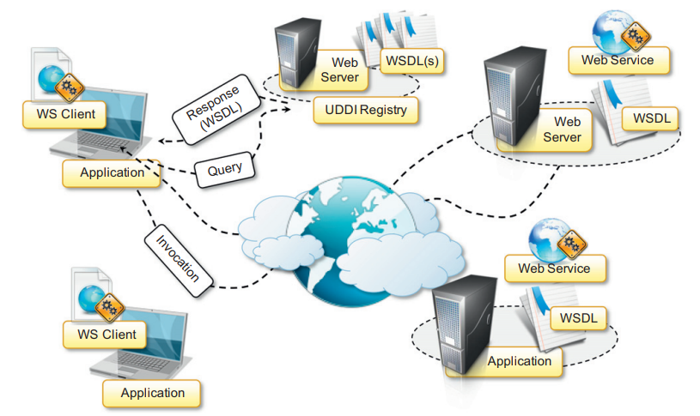

**Web Services Technologies Stack:**

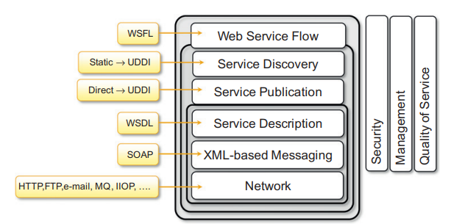

SOA: Standardized service contract, loose coupling, abstraction, reusability, autonomy, lack of state, discoverability, composability.